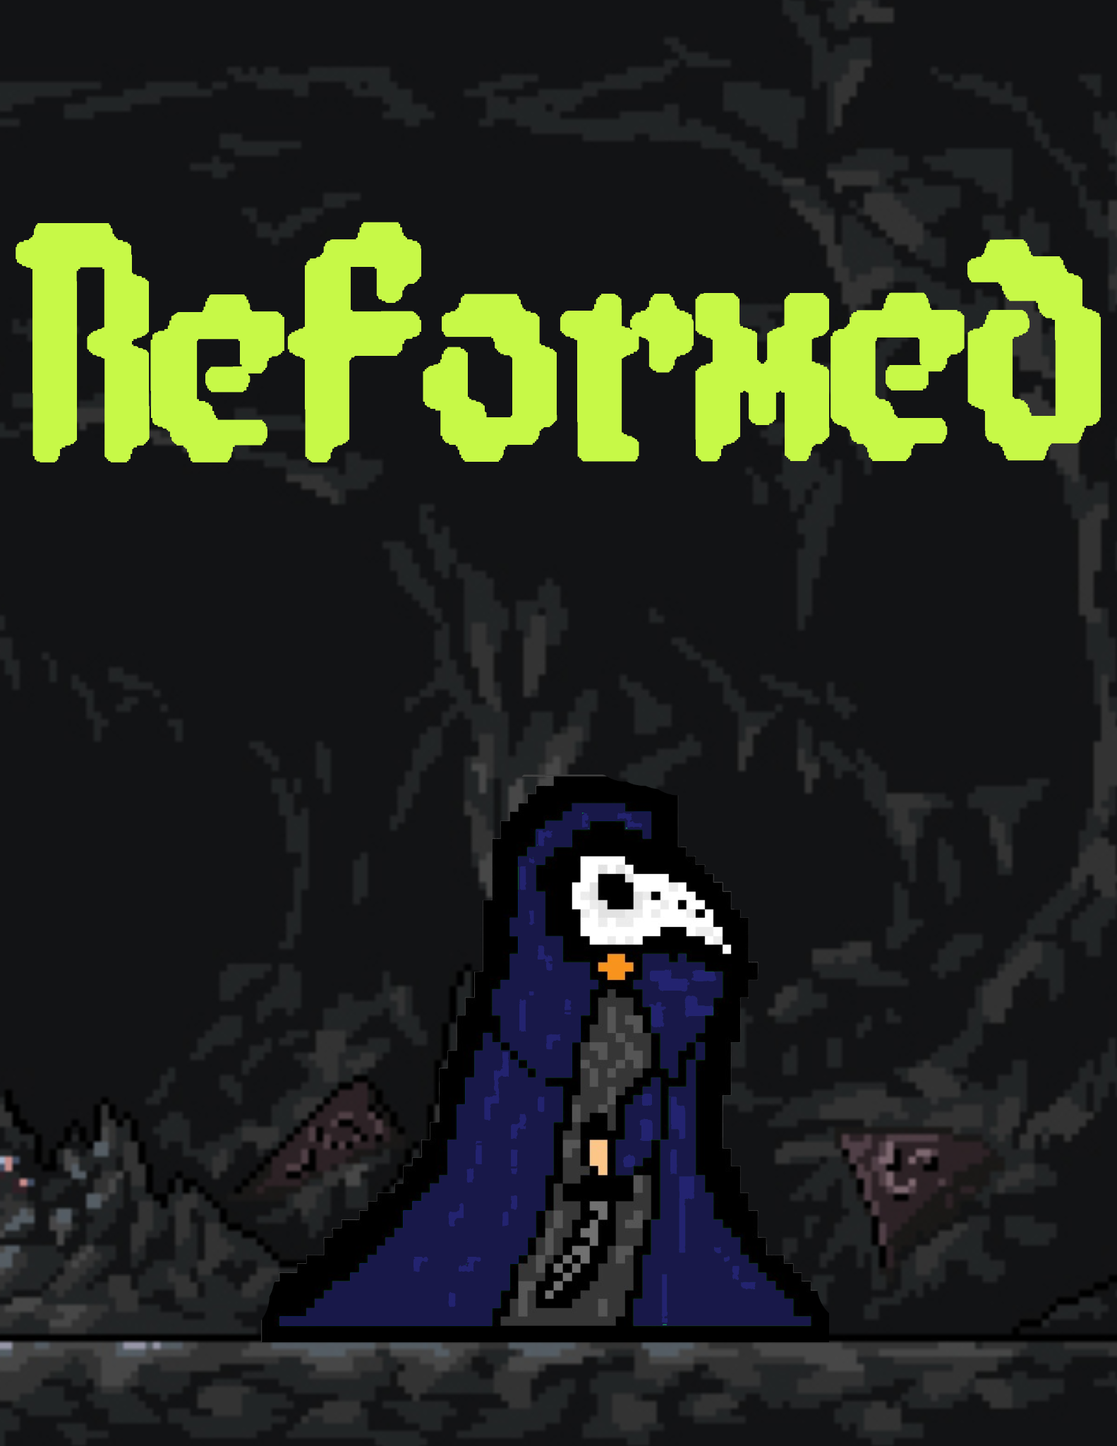

Team 16

Shaohang Song, Harlan Sturzenegger, Eric Truong, and John Paul Young

1. HIGH CONCEPT………………………………………………………………………………………3

1.1 “Two Sentence Pitch”………………………………………………………………………3

1.2 “Two Minute Pitch”………………………………………………………………………….3

2. GAMEPLAY OVERVIEW……………………………………………………………………………..3

2.1 Game Loop Explanation …………………………………………………………………..3

2.2 Movement …………………………………………………………………………………..4

2.3 Attacks……………………………………………………………………………………….5

2.4 Other ………………………………………………………………………………………...5

3. ENEMY OVERVIEW…………………………………………………………………………………..6

3.1 Normal enemies…………………………………………………………………………….6

3.2 Boss enemies……………………………………………………………………………….7

4. ENVIRONMENT AND LEVEL DESIGN OVERVIEW……………………………………………...9

4.1 Level Sequence……………………………………………………………………………...9

4.2 Environment designs………………………………………………………………………..9

5. ART DIRECTION……………………………………………………………………………………..10

5.1 Inspirational References………………………………………………………………….10

5.2 Sprite design ideas………………………………………………………………………..10

6. TIMELINE AND MILESTONES……………………………………………………………………..11

7. TEAM BIO……………………………………………………………………………………………..11

**Changes**

* Remove references to other games in the “two-sentence pitch”
* Replaced the 2nd paragraph in “two-minute pitch” from the story introduction to one focusing on the games two main pillars of combat and story
* Added images to gameplay overview to show controls and mechanics
* Added images enemies and to level design

**High Concept**

"Two Sentence Pitch"

Play as a trapped adventurer in a 2D action platformer with gothic horror, pixel art graphics. Run, jump, hook-shot, slash, and shoot grotesque monsters and bosses as you explore an expansive cave system under a ghost town. Will you be able to claw your way up out of the cave and get revenge on the person who led you here or will you suffer the same fate as the enemies you fight?

"Two Minute Pitch"

“Re-formed” (working title) is a 2D single-player action platformer where the main character must explore a massive cave system under a ghost town while fighting creatures and monsters with a combination of close-range stabs and crossbow shots.

The game has a strong focus on combat and strategic use of the player’s items and weapons. Our goal is to make the game’s combat (our major game loop) fun and reactive to the player. One way we are adding this aspect is an attack timing mechanic discussed in the gameplay overview. Another key aspect we want to incorporate is a clear narrative/story to the events of the game. We have already planned an interactive intro tutorial and when/where weapons and items are acquired. The player will be introduced to the plot as the story unfolds including a starting level to get used to controls, an escape sequence to show melee attack, etc.

The player only starts with a short-range but high damage knife. The weapons/items the player gets will determine the enemies in an area. When you start, the only enemies are blood slimes that can do contact damage. After/during that area the player picks up a hook shot (shoots a projectile into a surface and gets pulled to it) as a method of dodging projectiles and traps. Now the player has a method to dodge, goblins with crossbows will attack from a distance. After a goblin boss is defeated the player will get their crossbow.

After equipping yourself with weapons you have found, can you fight your way out of the cave and up into the mansion you started at?

**Gameplay Overview**

The game is an action platformer that unlocks new areas when more items/weapons are collected. A main mechanic we would like to add is a rhythm to the player’s attack to prevent spam. We plan for a weapon to do less damage if you spam it and have damage reset back to default after waiting a second (TBD)

Game loop

Like we said before the main core game loop is the combat be that the normal or boss enemies. We plan for enemies to occasionally drop health kits and weapon upgrades (TBD)

| **Player Controls** |  |
| --- | --- |
| Movement | Examples |
| **A and D keys**, Moves the character left and right when held down |  |
| **Spacebar key**, Makes the character jump (Metroid style jump) |  |
| **C key**, Sends out a hook shot and player will get pulled to where it collides |  |
| Attacks |  |
| **Left Pressed**, Melee attack with a knife (short-range, high damage) |  |
| **Right Pressed**, Fire a crossbow bolt (projectile, long-range, lower damage) |  |
| Other |  |
| **E key**, Used to interact with the world or environment (dialogue, pick up items, activate, etc) |  |
| **Damage mechanic,** If the player spams one attack rapidly the damage of the attacks goes down temporarily |  |

**Enemy Overview**

Combat will be one of the main focuses of the game as a way to challenge the player but also allow the player to have fun coming up with combos and strategies. Each area will have its own set of enemies and will be placed during level design.

| **Enemy Design** | **Current Sprites or Insperation** |
| --- | --- |
| General Enemies |  |
| Traps |  |
| Design: Spikes, torches, acid pits  Attack: Collision damage, Low Damage |  |
| Blood Slime |  |
| Design: Blood color slimes with large mouths  Movement: Hops around, if in range of player start moving to them  Attack: Collision damage, Low attack  Health: Low Health |  |
| Goblin |  |
| Design: Very skinny with ragged clothes  Movement: Walk back and forth if the player is not near  Attack: Crossbow attacks, fire if the player is in range  Health: Medium Health |  |
| Puss Zombie |  |
| Design: Tall and lanky, translucent puss sacks  Movement: Walks for a bit, stays still for a while looking around, repeat  Attack: Lunges if in range of the player, Low Poison Damage(6 seconds)   * Heath kit stops poison   Health: Medium Health |  |
| Bosses (All bosses have arenas where doors lock) |  |
| Goblin Captain |  |
| Arena: Ruined city center that was sunk under the mansion, filled with goblins cheering on the Captain  Design: Ship captain hat and coat, strong upper body, and peg leg  Attack: Crossbow, high attack rate, low damage   * Summon weaker goblins   Movement: Avoids player if it gets too close |  |
| Horror-punk Spider |  |
| Arena: a dark room with webs, high ceilings, twice the size of the captain’s arena  Design: Mix of biological and mechanical parts, hairy version of limbo spider and base is like a tank shell  Attack: Spawns enemies and items   * Unleashing machine proximity bombs(High Damage), shoot/melee to destroy * Mini Spiders that do small contact damage(Low Damage, Low HP)   Movement: Phase change to a wall climber at half health |  |
| Mad Scientist |  |
| Arena: Bell Tower  Design: A future version of the player, in dark clothes, mask under the mask, Similar size to the captain  Attack: A better version of main character attacks, sword, better crossbow  Movement: Hookshot and attacks while flying |  |
| Secret Boss ;) |  |

**Environment and Level Design Overview**

* Level Design:
  + Start by waking up in the mansion
    - Learn basic movement
  + Fall down a pit (level transition)
    - Find a knife in a body
    - Slash through a wooden barricade
  + Dark dank cave, moss, skeletons, and blood
    - Introduce blood slime
  + The next area is goblin focused, underground vegetation, ruins of houses
    - Introduce goblins
    - Captain Arena is a ruined town center, goblins in the background cheering on the Cap
  + Spiders dens, blood, mechanical parts, toxic
    - Introduce spiders and puss zombies
    - Horror-punk spider Arena, high ceilings, twice the size of captain’s arena
    - 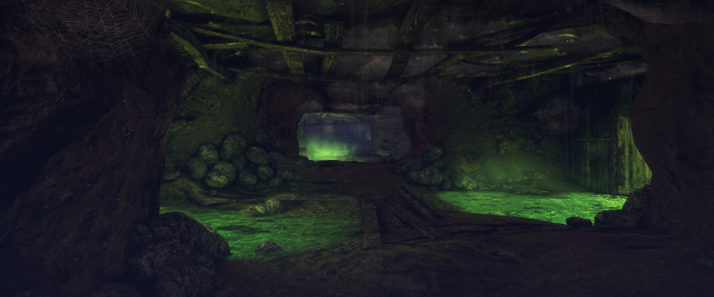
  + Head back into the mansion and the only way out is the belltower
    - Final boss room, Big bell at the top, the same height as spider arena but not as wide
  + Ends at the final boss
* Environment
  + The general environmental art is described in level design

**Art Direction Documentation**

* Our 2D pixel art will be based on the aesthetics of Hollow Knight, Dark Souls, and Dead Cells. We want the design to be gothic horror and have technology mixed with biological parts. The game will have backgrounds that incorporate the themes of the levels goo that pulsates, old ruined houses of the original town, blood and mech parts, and a lot of bodies

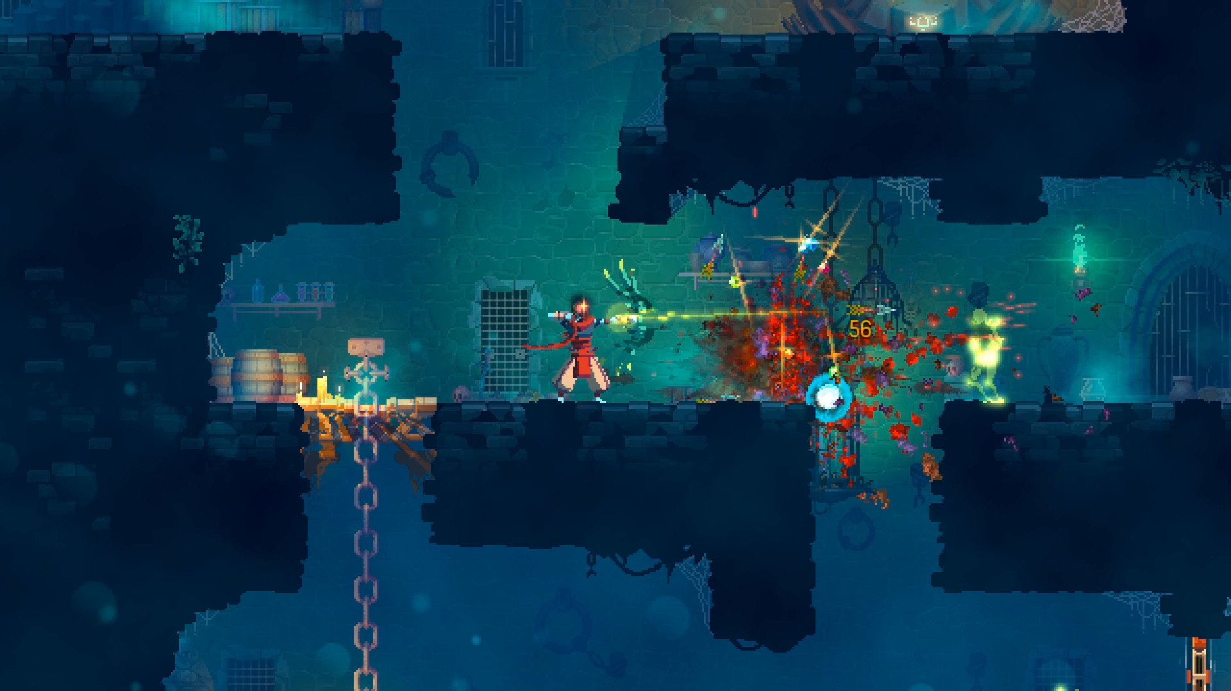

* Dead Cells

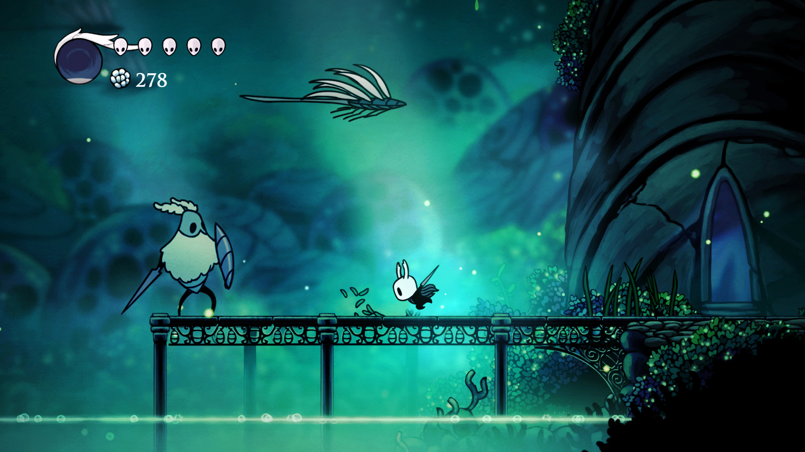

* Hollow Knight

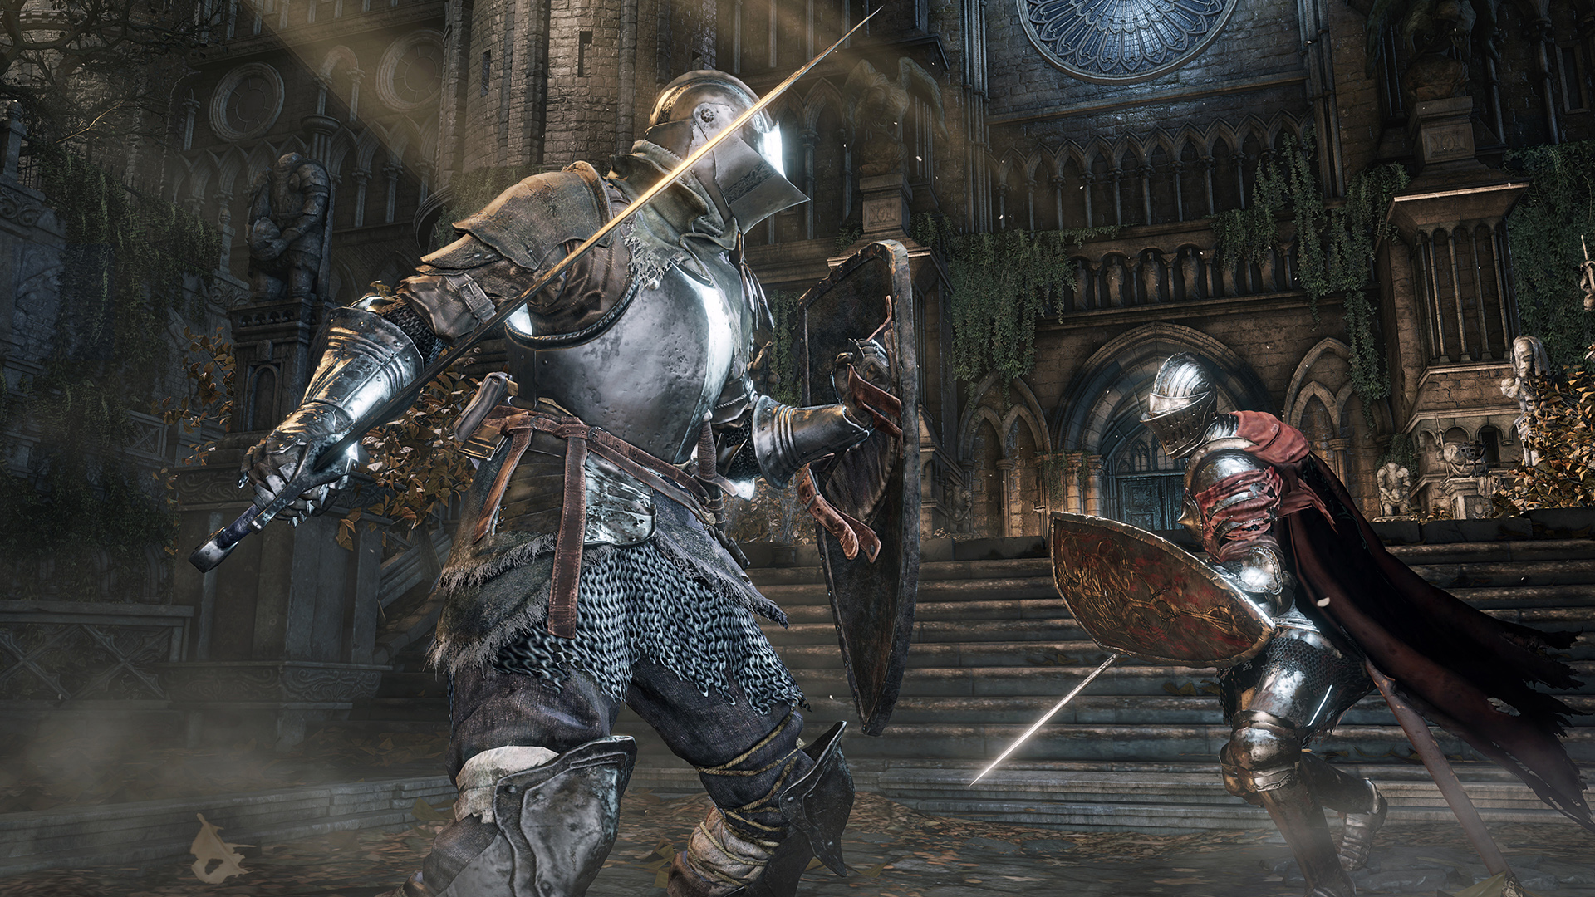

* Dark Souls

We plan to use a unique style for the main character by creating a 3D model and converting it into 2D sprite animations

**Approximate Timeline and Milestones**

* Meet every week to discuss and show work
* 10/15: Player Sprite and Background Concepting/Creation, Research mechanics (gravity, Ai)
* 10/22: Basic Movement and Test Room
* 10/29: Build Real levels
* 11/5: Build Real levels
* 11/12: Enemies implementation
* 11/19: Enemies implementation/Bosses
* 11/26: Playtesting/Fixing/Finalize

**TeamBio and Excepted contribution fields**

* Harlan Sturzenegger
  + Producer, Secondary Coder, Lead Designer
  + Schedule meetings, manage the timeline
* Eric Truong
  + Coder, UI/UX Designer, UI Coder
  + Creates sound effects for the player/enemies and makes the pause and main menus. Does general coding.
* John Paul Young
  + Art design, Additional coder, Level designer
  + Works with the team to put together sprites/animation to sprites.
* Shaohang Song
  + Blue map design, secondary art design.
  + Design game process story